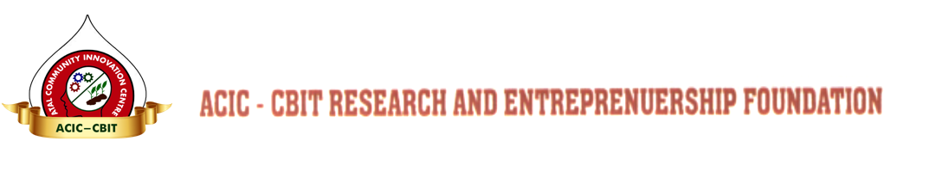
ACIC-CBIT RESEARCH AND ENTREPRENEURSHIP FOUNDATION

Chaitanya Bharathi P.O., Kokapet (V), Gandipet (M), Hyderabad - 500 075, Telangana State.

=======================================================================================

Affix your latest passport size photograph (Self attested) for hard copy and scan copy on e-application
Advt. No.
APPLICATION FORM

APPLICATION FOR THE POST OF : CENTER HEAD, ACIC-CBIT

- Name in full with Surname : ___________________________________

- Father’s / Husband Name : ___________________________________

- Date of Birth & Age (in Christian era) : ___________________________________

4. Place of Birth : ___________________________________
5. Postal Address for Communication : ___________________________________

___________________________________

___________________________________

6. Email ID : ___________________________________

7. Mobile No. : ___________________________________

8. State your present Location, and whether
willing to relocate if currently stationed :____________________________________
out of Hyderabad:

9. Give particulars of all Examinations passed Degree / Diploma obtained (commencing with the Intermediate Examination). - (Copies of Certificates to be enclosed)

S. No. | Examination or  Degree | Name of the College and University | Year of passing | Class & Percentage | Subjects taken for Specialization | Remarks(Whether done in Full time/part time/ Distance mode/ Correspondence)

10. Prior Experience to Manage and execute the activities of incubation center/ R&D center, Prototyping and Fab Lab: Give in reverse chronological order details of your previous experience.
- ( latest pay slip to be enclosed)

S. No. | Name & Address of the Organization | Designation | Duration of Employment |  |  | Last Drawn salary | Reasons for leaving the Post
 |  |  | From | To | Total (Yrs)
1.
2.
3.
4.
5.

11. Experience in Facilitate collaborations, MoUs, technology tie-ups, commercialisation, business development(accelerators)to support incubation center’s day-to-day operations and sustainability
- ( List out major achievements)

12. Experience in developing and manage a network of entrepreneurs, start-ups, mentors, institutions, networking with funding agencies, angel investors, Banks and industries- ( List out major achievements)

13. Experience in organizing training programs through workshop, mentorship, networking, seminars, IPR Related activities- ( List out major achievements)

14. Details of Enclosures:
(i)
(ii)
(iii)
(iv)
(v)

- Names of two Persons with their Address / Designation
(Including Email ID & Mobile Number) to whom reference
can be made about the Candidate :

- ___________________________________ (ii) ____________________________________________

- If selected and appointed please specify the time you require for joining duty: ____________________

- Would you like your application to be considered for the post of young professional? ---------------

Place:
Date: Signature of the Candidate

================================================================================

DECLARATION TO BE SIGNED BY THE CANDIDATE

I hereby declare that the particulars furnished in this Application are true to the best of my knowledge.

Date: Signature of the Candidate
================================================================================

